AI Powered Intelligent Hospital Patient Flow Management System
BLOCK DIAGRAMS - ALL

Student | Hall Ticket No.
A. RAMU | 23K91A6715
B. RUSHI | 23K91A6720
B. RAJ KUMAR | 23K91A6725
A. PRABHAS | 23K91A6703
Under the guidance of [GUIDE NAME]
Department of Computer Science and Engineering (Data Science)
[COLLEGE NAME]
[ACADEMIC YEAR]

Diagram Inventory
The following diagrams were generated from the implemented SQLAlchemy entities, FastAPI routes, services, model inference functions and React role flows. They describe the checked-in code rather than a proposed future architecture.

System architecture
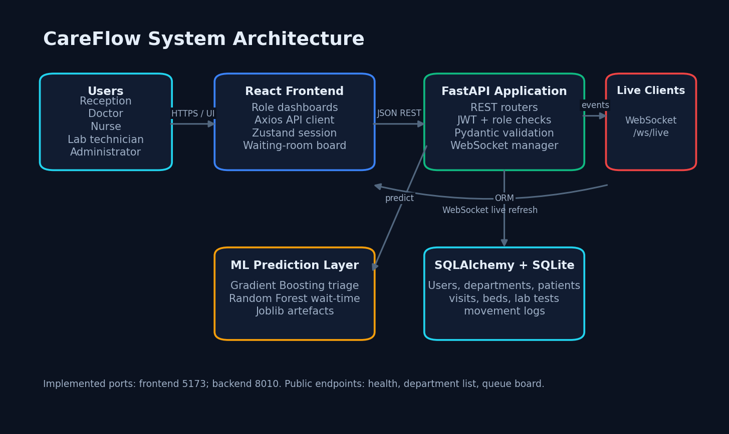
Figure 1. System architecture
The React client calls FastAPI REST routes, which coordinate JWT role checks, SQLAlchemy persistence and the two saved estimators. WebSocket events refresh live clients.

High-level patient workflow
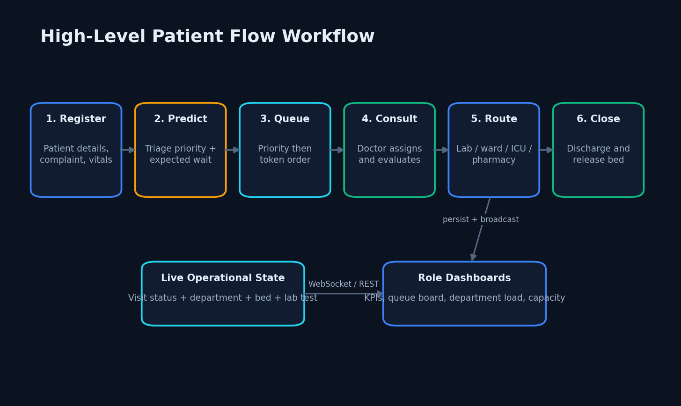
Figure 2. High-level patient workflow
The operational path runs from registration and prediction through priority queueing, consultation, routing and closure.

DFD Level 0
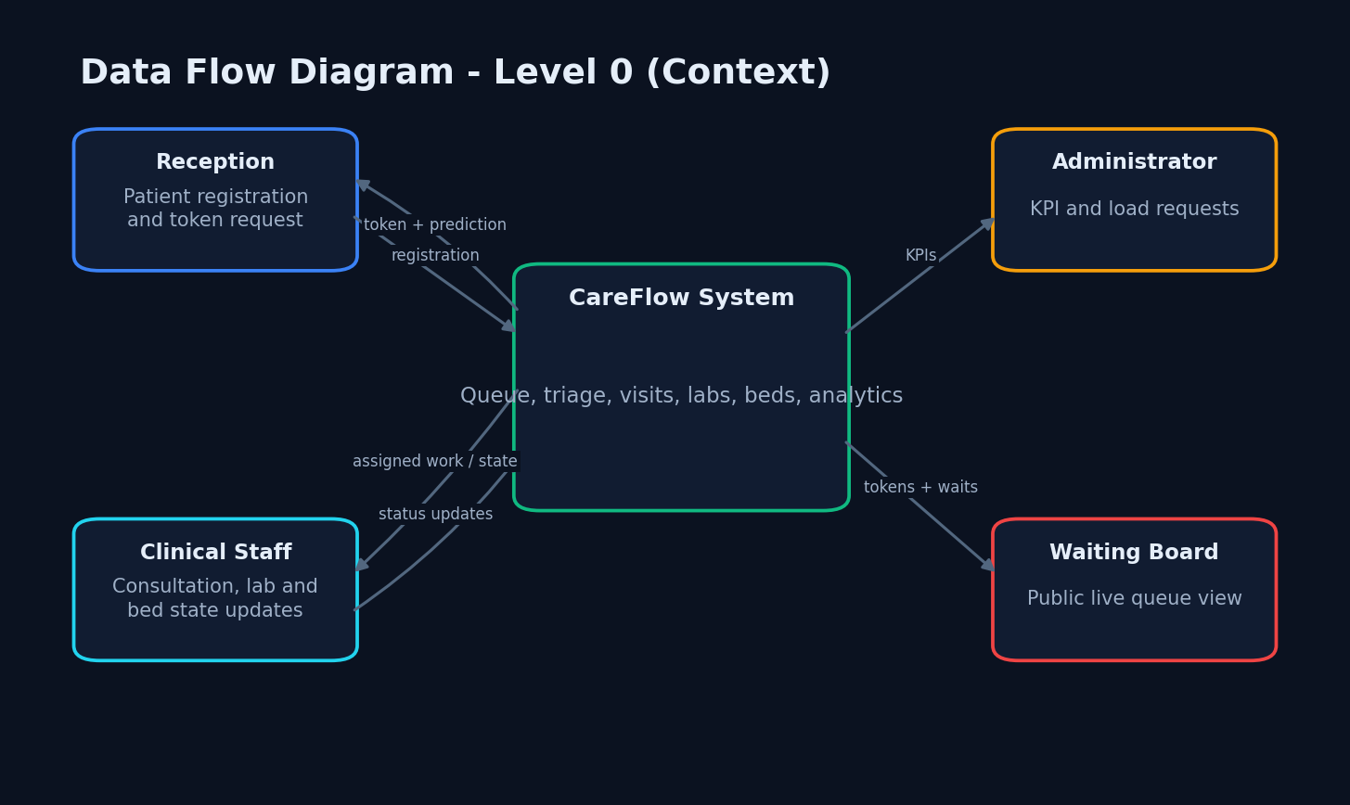
Figure 3. DFD Level 0
The context view shows reception, clinical staff, administration and the waiting board exchanging information with CareFlow.

DFD Level 1
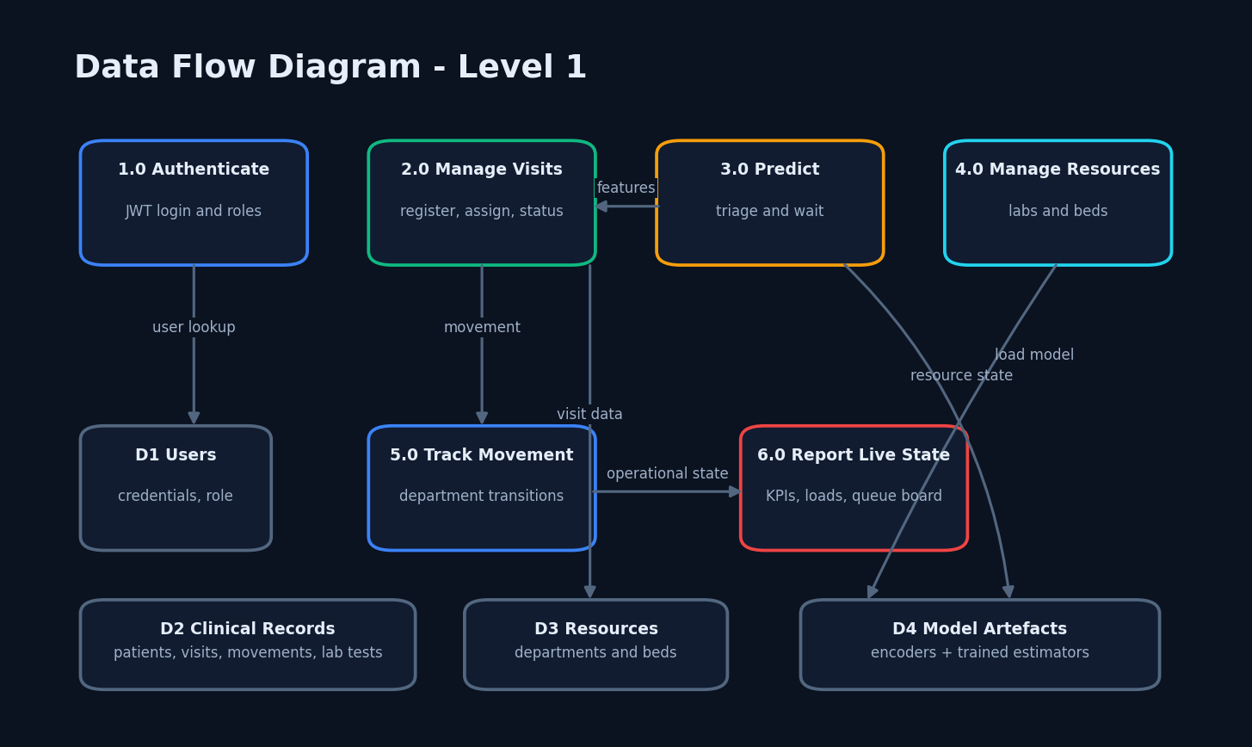
Figure 4. DFD Level 1
The system is decomposed into authentication, visit, prediction, resource, movement and reporting processes.

DFD Level 2
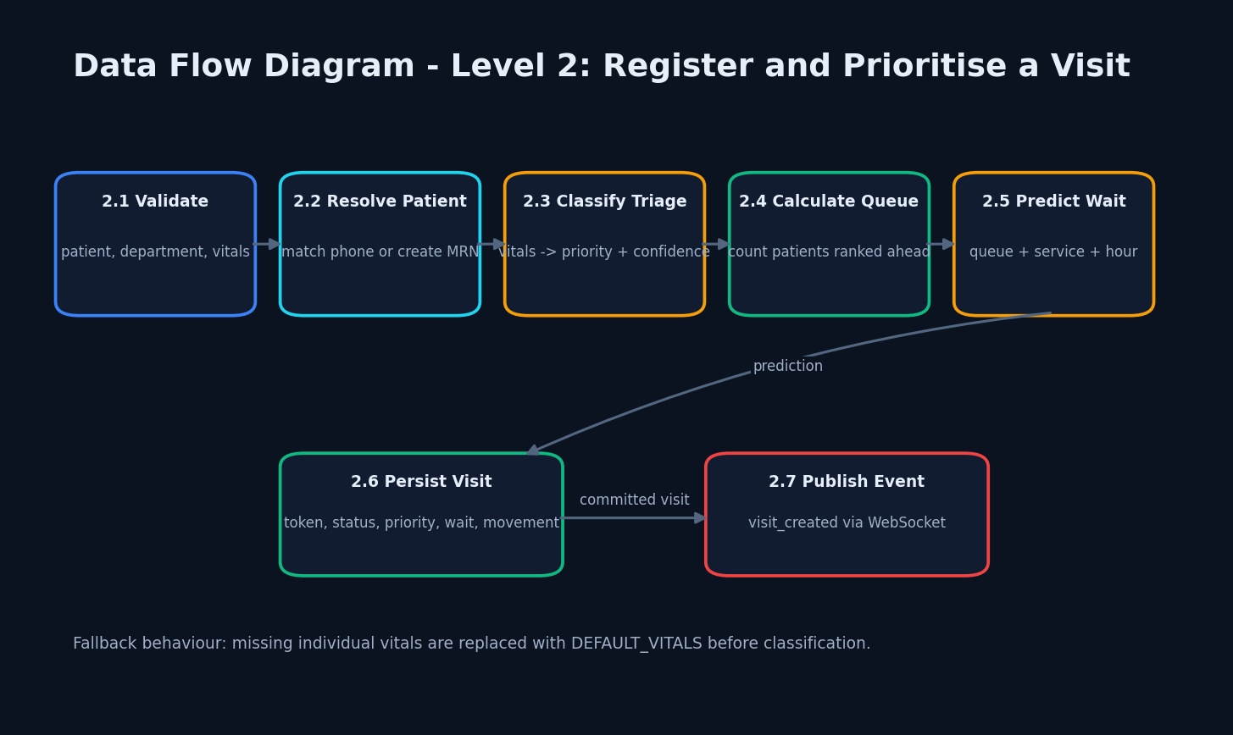
Figure 5. DFD Level 2
Visit creation validates inputs, resolves a patient, predicts priority and wait, persists the visit and publishes an event.

UML class diagram
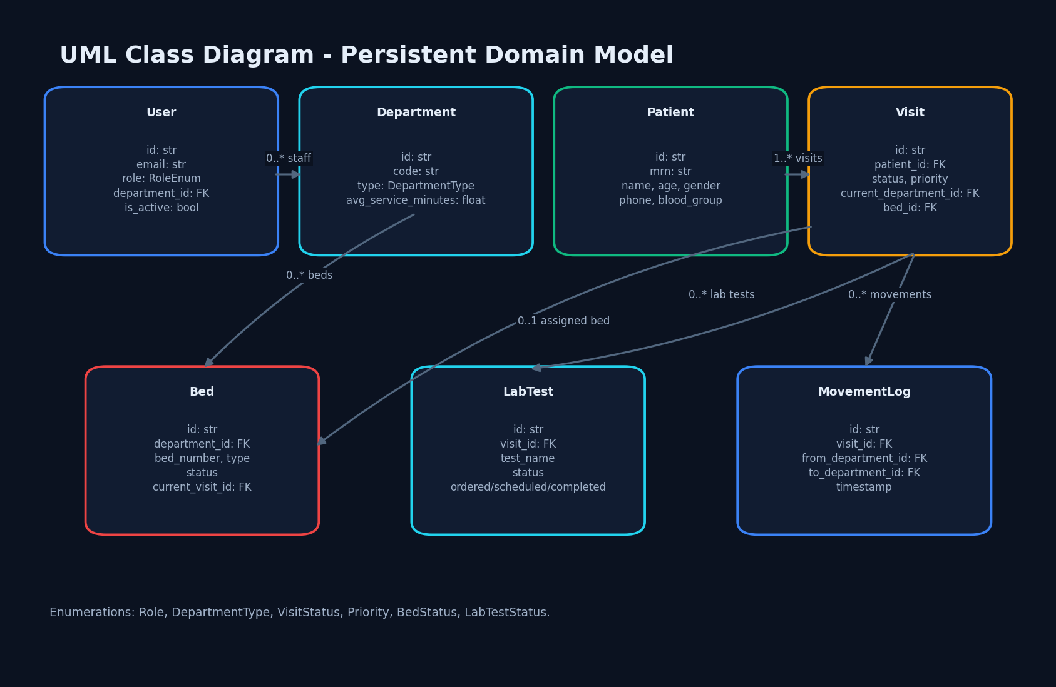
Figure 6. UML class diagram
The class view records the persistent model types and their operational relationships.

Registration sequence
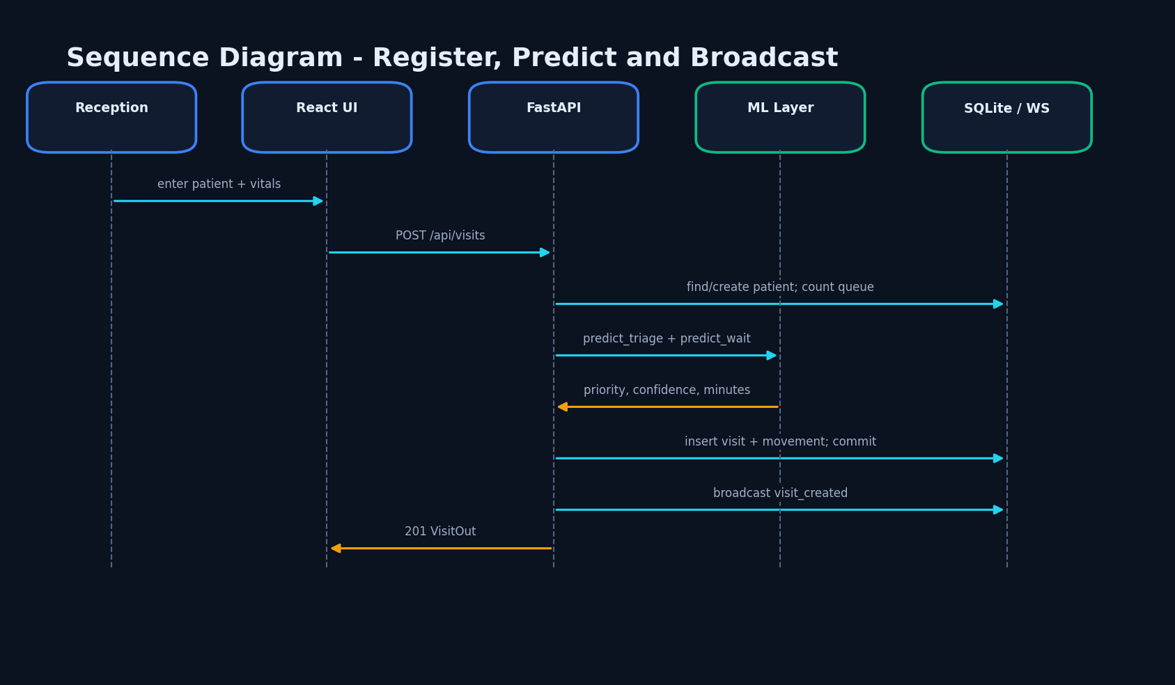
Figure 7. Registration sequence
Reception, frontend, API, ML layer, database and WebSocket participate in one registration transaction.

Use-case diagram
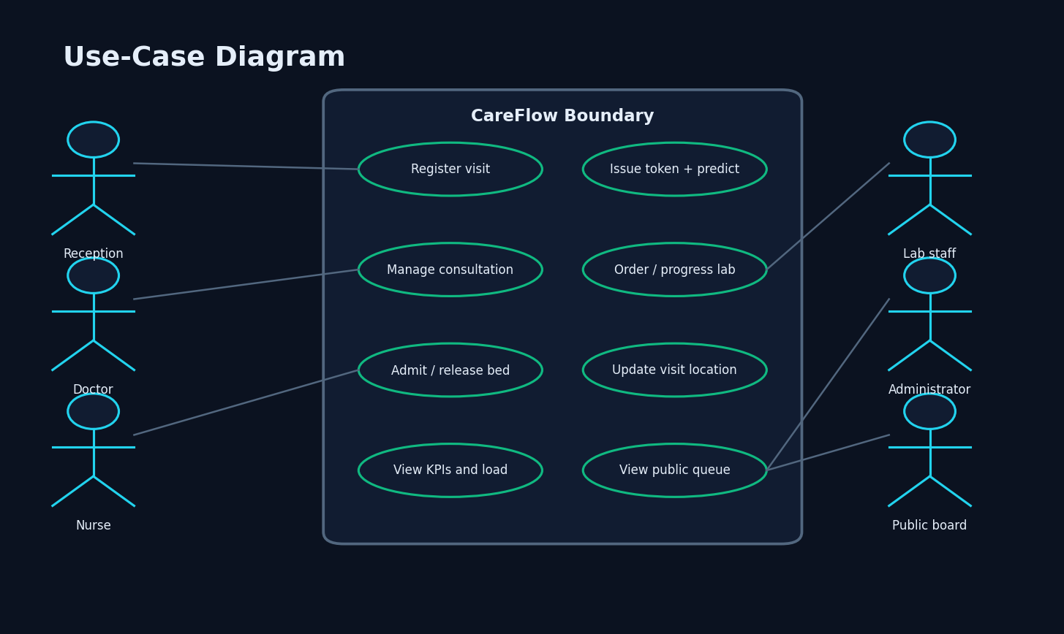
Figure 8. Use-case diagram
Each role is linked only to the functions implemented by its dashboard and API permissions.

Entity-relationship diagram
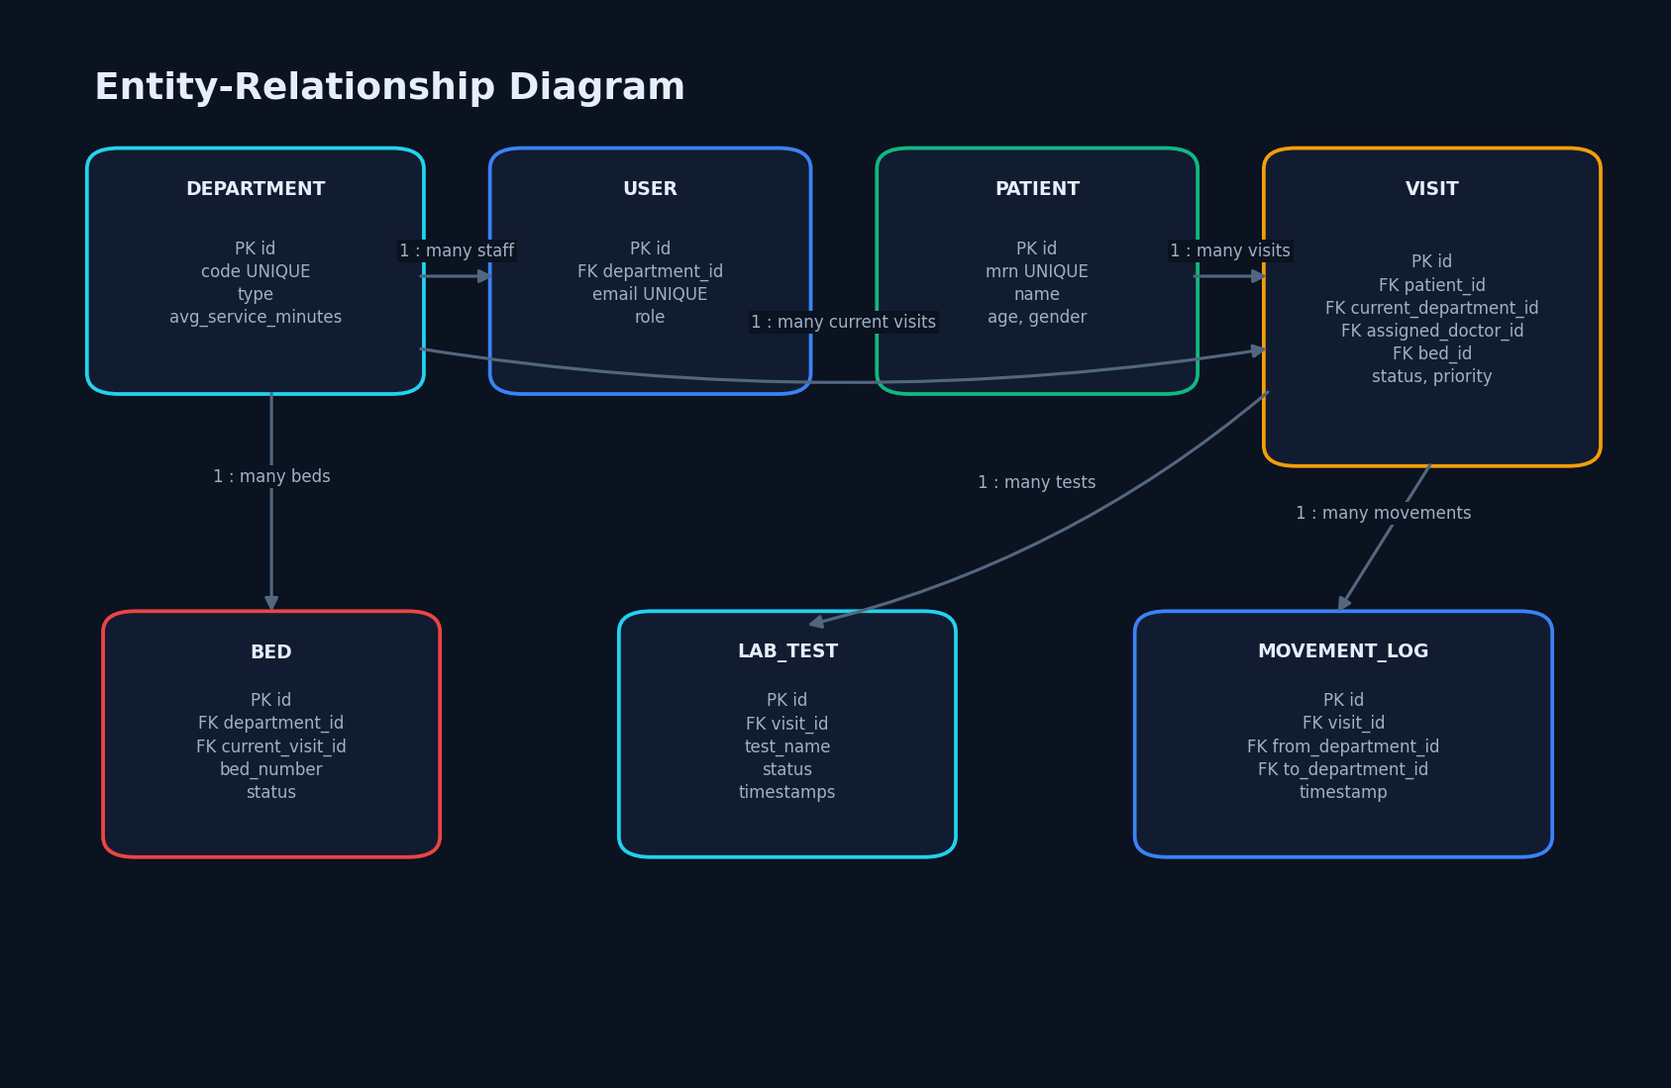
Figure 9. Entity-relationship diagram
Foreign-key paths connect departments, staff, patients, visits, beds, tests and movement logs.

Core algorithm flowchart
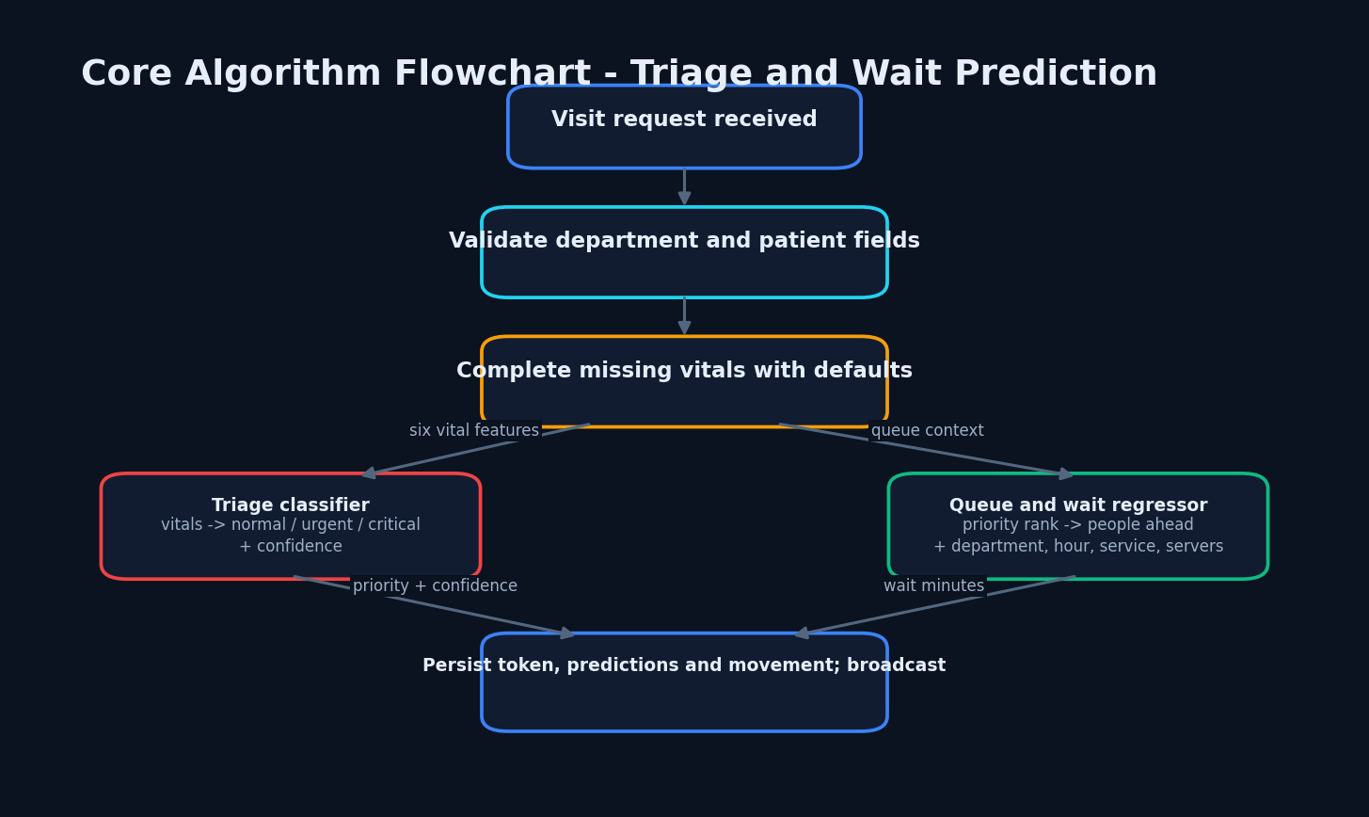
Figure 10. Core algorithm flowchart
The prediction flow combines vital-sign classification and queue-context regression before persistence.

